**2- Clinical Data**

**(Histologic, molecular subtypes)**

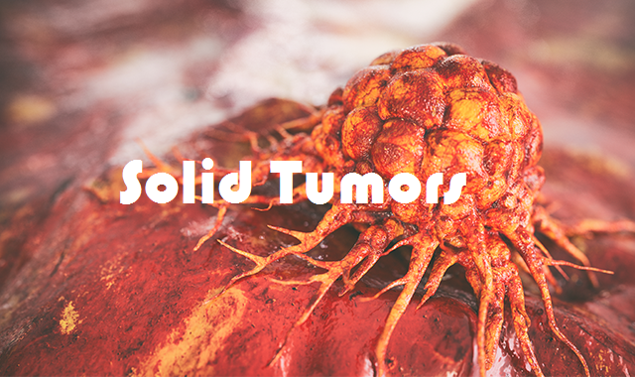

**Breast Cancer**

**Histologic subtypes:**

* Duct carcinoma insitu
* Lobular carcinoma insitu
* Infiltrating ductal carcinoma
* Infiltrating lobular carcinoma
* Mucinous carcinoma
* Tubular carcinoma
* Medullary carcinoma
* Metaplastic carcinoma
* Papillary carcinoma

**Molecular Subtypes:**

* **ER: +ve or –ve 🡪 score:**
* **PR: +ve or –ve 🡪 score :**
* **HER2: +ve or –ve 🡪 score:**

**Non–Small Cell Lung Cancer**

**Histologic subtypes:**

* Adenocarcinoma
* Squamous cell carcinoma
* Adenosquamous carcinoma
* Large cell undifferentiated carcinoma

**Molecular subtypes:**

* EGFR: positive or negative
* ALK: positive or negative
* ROS-1
* K-RAS

**Small cell lung cancer**

**Histologic subtypes**

* No

**Molecular subtypes:**

* No

**Malignant Pleural Mesothlioma**

**Histologic subtypes:**

* Epithelioid
* Sarcomatoid
* Mixed

**Molecular subtypes:**

* No

**Thymoma / Thymic carcinoma**

**Histologic subtypes:**

**Thymoma:**

* A: Spindle- or oval-shaped cells without nuclear atypia and without nonneoplastic lymphocytes
* AB: Mixed histology, with regions of type A and other regions of type B
* B1: Epithelioid cells, enriched with nonneoplastic lymphocytes; features resemble normal thymus
* B2: Increased numbers of plump epithelioid cells enriched with nonneoplastic lymphocytes
* B3: Round or polygonal epithelial cells with mild atypia (well-differentiated thymic carcinoma)
* C: Prominent cytologic atypia and nonthymic histologic features (thymic carcinoma)

**Thymic carcinoma:**

* Squamous cell carcinoma
* Sarcomatoid carcinoma
* Undifferentiated carcinoma
* Lymphoepithelioma-like carcinoma
* Neuroendocrine carcinoma: large cell and small cell

**Molecular subtypes:**

* No

**Thyroid Cancer**

**Histologic subtypes:**

* differentiated papillary
* differentiated follicular
* differentiated Hürthle cell.
* medullary
* anaplastic

**Molecular subtypes:**

* No

**Adrenocortical Carcinoma**

**Histologic subtypes:**

* No

**Molecular subtypes:**

* No

**Pheochromocytoma**

**Histologic subtypes:**

* No

**Molecular subtypes:**

* No

**Bladder Cancer**

**Histologic subtypes:**

* Urothelial carcinoma
* Squamous cell carcinoma
* Adenocarcinoma
* Small cell **carcinoma**

**Molecular subtypes:**

* No

**Prostate Cancer**

**Histologic subtypes:**

* adenocarcinoma.
* Sarcoma
* small cell carcinoma

**Molecular subtypes:**

* No

**Gleason score:**  ( number)

**Testicular Cancer**

**Histologic subtypes:**

* Germ cell; seminoma
* Germ cell; nonseminoma
* Embryonal cell
* Choriocarcinoma
* Yolk sac
* mature Teratoma
* immature Teratoma
* Stromal tumors:
* Sertoli cell tumor
* Leydig cell tumor
* primitive gonadal structures

**Molecular subtypes:**

* AFP : (number)
* LDH : (number)
* Beta HCG : (number)

**Renal Cell Carcinoma**

**Histologic subtypes:**

* Clear cell tumors.
* Non clear cell tumors
* Papillary
* chromophobe
* collecting duct tumors

**Molecular subtypes:**

No

**Cancer Esophagus**

**Histologic subtypes:**

* Squamous cell carcinoma
* Adenocarcinoma

**Molecular subtypes:**

* **HER2 :** Positive or Negative (score: number)

**Tumor site:**

* Lower third
* Upper third
* Mid-esophagus

**Gastric Cancer**

**Histologic subtypes:**

* Intestinal type Adenocarcinoma
* Diffuse type Adenocarcinoma

**Molecular subtypes:**

* **HER2 :** Positive or Negative (score: number)

**Tumor site:**

* Cardiac (GEJ tumors)
* Corporal tumor
* Antral tumor

**Colorectal Cancer**

**Histologic subtypes:**

* Adenocarcinoma
* Mucinous carcinomas
* Medullary carcinoma
* Signet ring cell carcinoma
* Non-adenocarcinoma
* Adenosquamous carcinoma
* Squamous cell carcinoma
* Spindle cell carcinoma
* Undifferentiated carcinomas,
* Neuroendocrine tumors (NETs)

**Molecular subtypes:**

* **K RAS:**  wild or mutant
* **N RAS :** wild or mutant
* **B RAF :**  wild or mutant
* **MSI :**  high or stable
* **HER2 :** Positive or Negative (score: number)

**Anatomic site:**

* **Right side**
* **Left side**
* **Rectum**